**COMP140 : Individual Creative Computing Project**

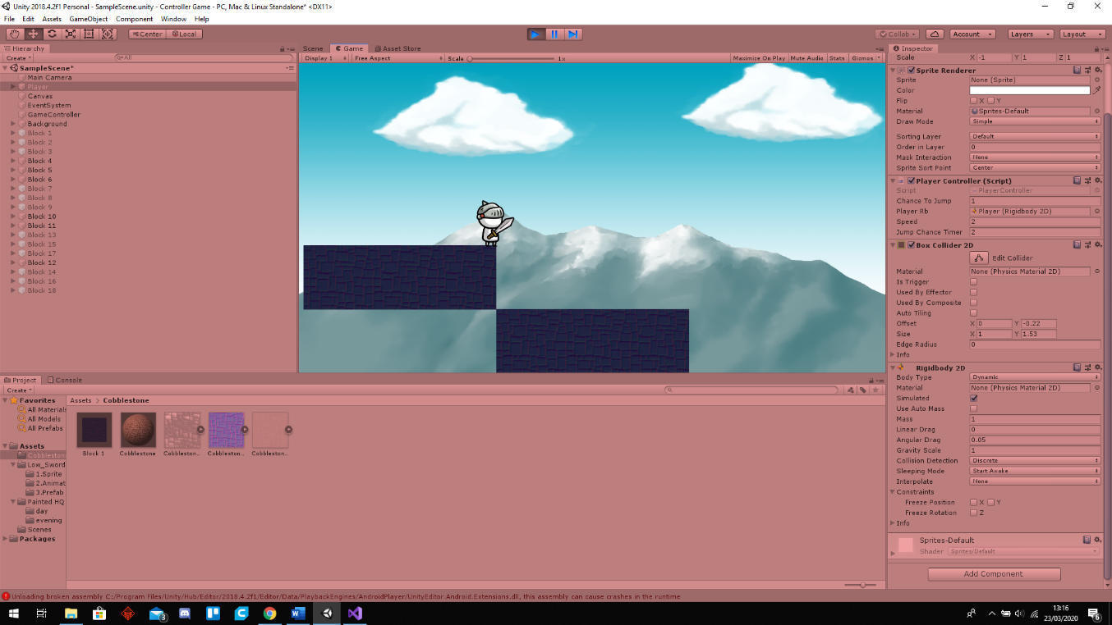Game Description:

This game is different to most game as instead of playing as the character, you instead play as the environment in order to lead the character to the end on the level safely.

In this game you will have to create a path for the character to get from one side of the screen to the other side of the screen whilst avoiding obstacles and collecting coins. The game will have a level based system, however every level will be randomly generated and therefore will never be the same as the last. The characters movements of running and jumping will also me randomised, your high score will be the highest level you get to and after the character dies 3 times it will go back to level one.

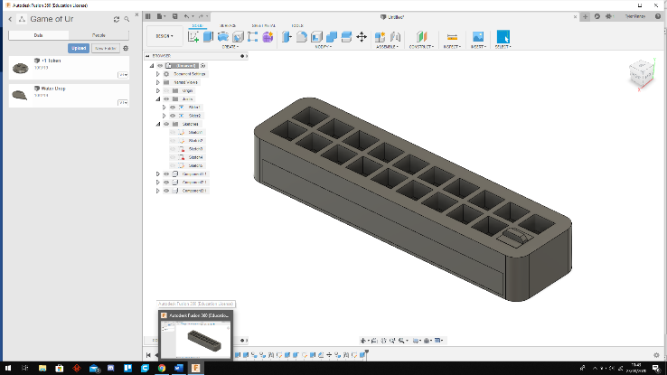

Controller Description:

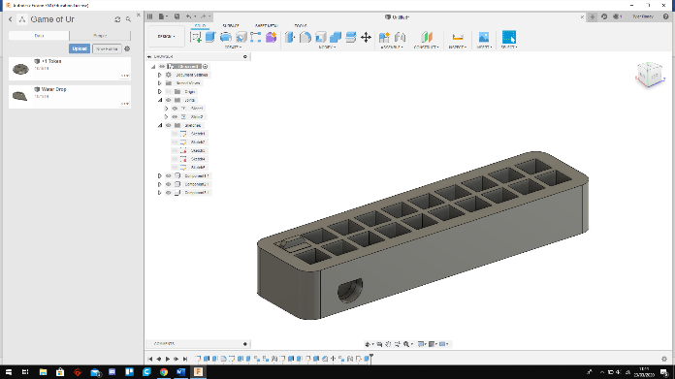The Controller will look fairly simple from the outside and will be able to completely encase the Arduino and all the components with a place for the power wire to come out the back. It will have a pull out draw at the bottom where the wires and Arduino will sit in order to protect them from the actions of the user.

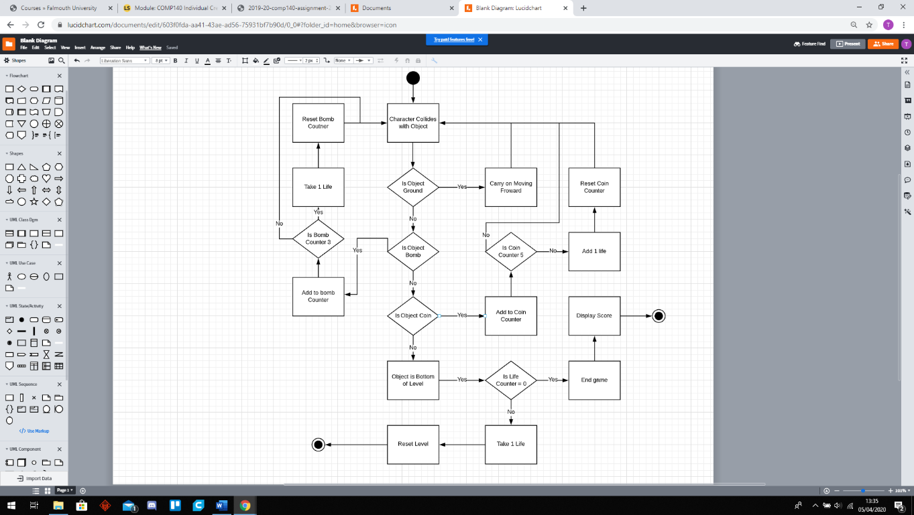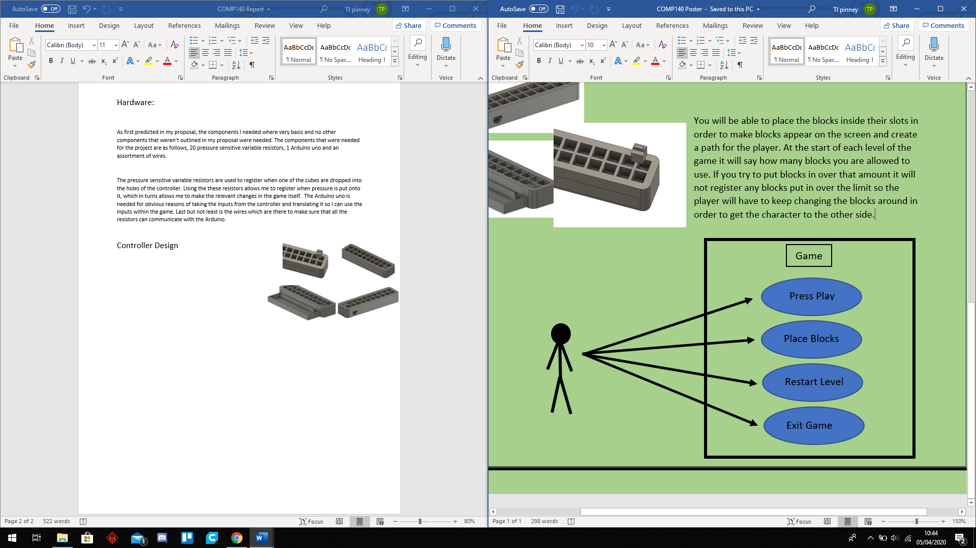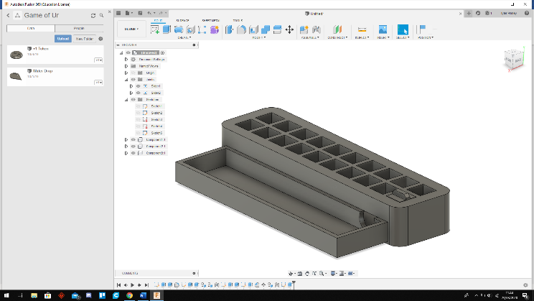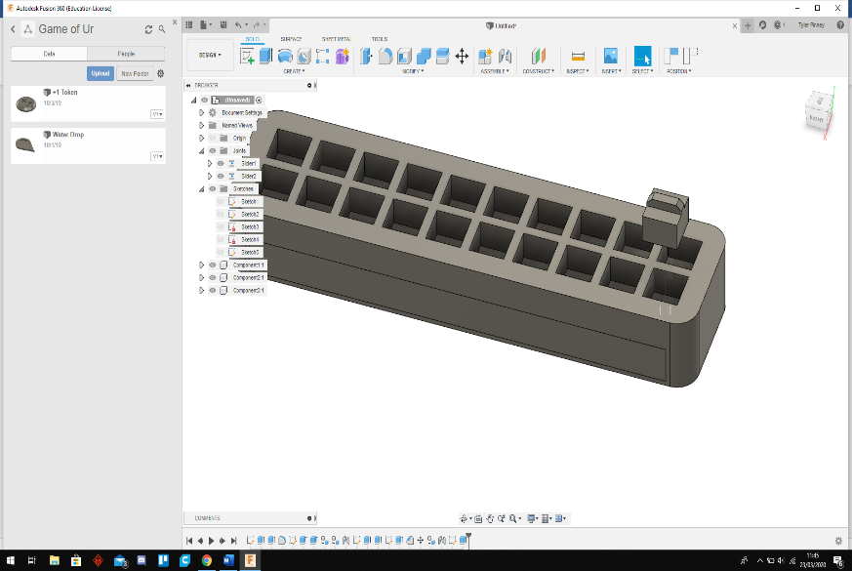You will be able to place the blocks inside their slots in order to make blocks appear on the screen and create a path for the player. At the start of each level of the game it will say how many blocks you are allowed to use. If you try to put blocks in over that amount it will not register any blocks put in over the limit so the player will have to keep changing the blocks around in order to get the character to the other side.